International Art Museums Online

By Fouad Riaz Bajwa

Technology has been changing the way we carry out our daily activities in life and with the World Wide Web, access to information has simplified which was once a great hurdle without such internet communication technologies in the past. Technolgy has also helped improve the state of art museums and collections by utilizing the World Wide Web. This article walks the readers through some of the famous international art museum and collections websites online.

Initially as these art collections came online a few years back they offered a minimum of images, lots of visitor information, and the inevitable sales shops. Within the past few years most of these museum sites have made an amazingly conscientious effort to digitalize their collections providing high resolution images which can be studied in detail, online educational materials and exhibits, and access to rarely exhibited treasures that are too fragile to be exposed to light or the public. The name of the game is exploring on your own. That's what art on the internet is all about. With these sites you can find yourself gazing lovingly at a painting by an artist nobody ever told you about or immersing yourself in the unfamiliar work by a much loved artist. Here are some of the serious and exciting sites which I found while planning out the FKM E-Museum Project over the past few months.

1. The Tate Galleries
url: http://www.tate.org.uk/

Definitely one of my favourites. From this website one can clearly see that the North Americans used to be the masters of creating blockbuster websites but now watch the British beat them at their own game. The Tate Britain is the greatest collection of British art in the world and the Tate Modern is England's greatest collection of modern art. The online images have reached a fantastic 8,000 with 500 being added each week out of a total of 25,000. This means all of Turner's work is online including the rarely exhibited drawings and watercolors. There is more art here than on any of the other sites and much more than you would ever see if you went in person to the Tate for a year.

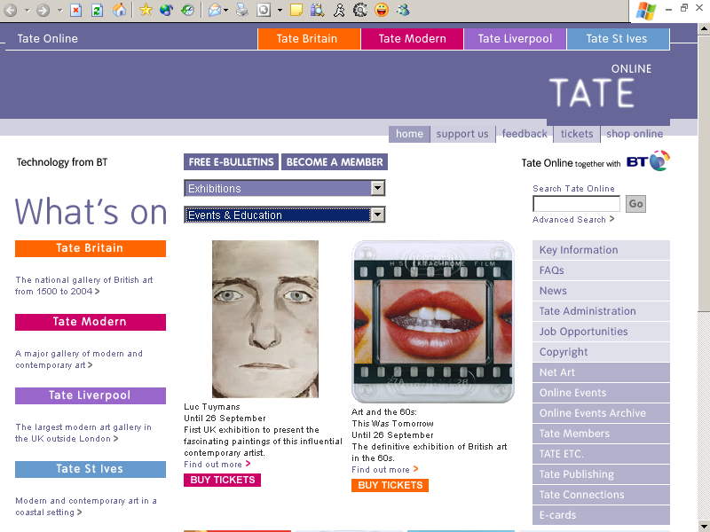

2. Metropolitan Museum of Art
url: http://www.metmuseum.org/

The Metropolitan is the Queen of North American art museums. With over 20 permanent departments beginning with Ancient Egypt through all stages of European art to the present, as well as covering Islam, Asia, and the Americas, the Metropolitan Museum is much more than a collection of European paintings. In fact, the Metropolitan Museum is one of the shining examples of an institution based on principles of high multiculturalism. The permanent departments are represented by 3,500 reproductions of works of art. And The Metropolitan Museum calls this is the first installment of what is expected to be a comprehensive visual catalog.

There is a director's tour of 25 objects representing highlights from the key departments. Or you can begin with any of the 21 collections choosing up to 50 items to view per collection. European painting, all 2,000 pieces, is completely accessible.

The images appear as thumbnails which can be enlarged, and the fine details studied with zoom capacity for most pieces. The image quality is good. The notes accompanying the work are said to be newly written for the site. Through one of its special features the Metropolitan Museum provides storage space for saving images you like. Educational materials are extensive and located in four separate departments and libraries. Explore and Learn is the place to begin for online adult and family educational needs as it tends to be drawn from current or past exhibits.

There is a site wide search. Surprisingly for an institution that prides itself on its great traditions, there is no history of the museum to be found online. All in all a splendid example of the seriousness and vitality of the history of art on the net. If the best way to see the Metropolitan Museum is to nibble on it for twenty minutes a day every day of the year taking in two or three sublime objects, then this web site seems designed for just such a regimen.

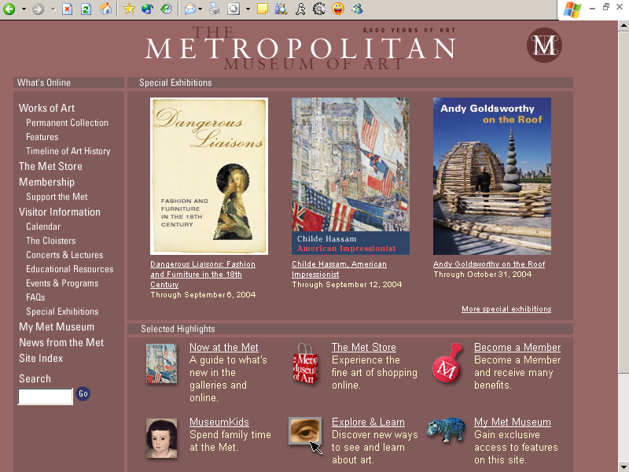

3. National Gallery of Canada
url: http://national.gallery.ca/

The Canadian Government like the British Government takes keen interest in promoting its national cultural heritage online and has developed this unique website for it’s art loving society. Indeed it’s one of those experiences that one remembers for a very long time.

Cybermuse, a fancy site within the site which requires registration and takes its time to download, may seem like a pain to work with but it is worth the effort. Cybermuse moves the National into the 21st century with high resolution images of many of the works of art in this first rate collection. It can be searched by artist, theme or gallery. I recommend you use broad categories like "Italian painting" to flush out what is there.

Be sure to check out the Cybermuse favorites section where works by Monet, Pissarro and van Gogh are found. It also includes clever and informative Quick Time movies on these painters.

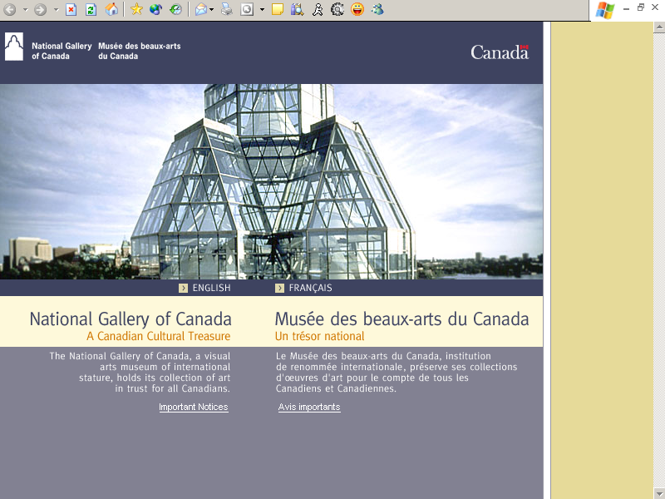

4. National Gallery of Art in London

url: http://www.nationalgallery.org.uk/

This extraordinary collection which represents the whole history of European painting is now virtually completely online. But there are a number of bugs which they need to fix. Don't be discouraged by results of simple searches that seem twisted. There are a number of tricks which will assist you searching this site. One is to use some broad search themes like altarpieces, landscape, still life, religious paintings, angels and lots of other stuff. These will work and will produce the results visitors are looking for.

Also hidden from view are the equivalent of three CD's produced in previous years by the Gallery of three of their greatest treasures: Eyck's Arnolfini Portrait, Renoir's The Umbrellas and Botticelli's Mystical Nativity. To access these exhibits, go to the Exploring Paintings section. There is also a Eurosearch function which allows you to search the Louvre, Hermitage, Van Gogh Museum, Mauritshuis and a few other web sites.

And you can download the whole catalog of their latest exhibit, Encounters: New Art from Old, which presents us with the reflections of contemporary masters such as Balthus, Bill Viola, Francesco Clemente, Lucian Freud, David Hockney among others as in the process of creating works inspired by paintings in the permanent collection. Truly an event in the world of art. I recommned you to be patient with this site it will eventually be a wonderful source of pleasure and enlightenment.

